37.72: In Eq. (37.23), 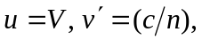 and so
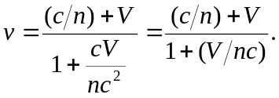
For V non-relativistic, this is
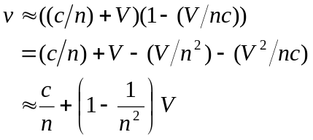
so 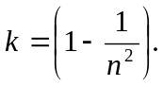 For water, 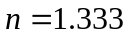 and 